ERP, CRM, and Complaint Management System for Real Estate

### Project Proposal



## Supervisor

Fatima Khalique

## Submitted by

Tauheed Butt

01-134191-068

Ahmad Hassan

01-134191-002

**Department of Computer Science,**

Bahria University, Islamabad.

March 6th , 2022

# Introduction

The proposed project is a centralized system for *Real Estate* businesses. This will bring together real estate project owners, shopping mall owners, their administration staff, customer relation staff and customers on a single platform. The project owners can showcase their buildings, colonies etc., by uploading the CAD[1] file of their project. The customers can view the 3D or 2D version of the project, which shop or apartment is available and then they can decide which shop or apartment they can buy. Moreover, customer relation services will also be provided on the proposed system.

# Objective

To provide a single platform where real estate business owners can showcase their projects and customers can view it and communicate with the project owners and make a deal online.

# Problem Description

The proposed project is a cross platform application which is going to bring together real estate business owners and their customers on a single platform. As we know that there are a lot of property businesses in the market and for customer, it is a long process to make a deal. Customer has to go to the office of the real estate owner, then they have to go to site for inspection, to take a look for what they are going to buy. Then after this long process, they make a deal. This process takes a lot of time. In this regard our proposed system will reduce this process into some clicks with mouse and taps on the screen. Our system will allow business owners to upload the project details along with CAD file so that customer can have an easy online inspection, then only the payment process will be left for them to handle in the office. The proposed project is going to be very helpful for the real estate business community and customers. Customer relation management will also be provided so that the queries of the customers can be solved online. Moreover, feature ERP[2] will also be available so that the process of payments installments also goes online. Although it will be little difficult for business owners to shift from traditional method but once they shift to proposed system, they will get great benefit from it.

# Methodology

The proposed system is going to be a cross platform application. There are two main users. Customer and Real Estate Project Owner. It will have the following main components:

* Login/Signup:  
  Customers, Project managers will have to login or signup to use the app. For this component we are going to use react native[3] and google and apple signup APIs.
* 3D view and details of the building:

This component is one of the main feature of our proposed system. Customers can view the project without signing up but to make a deal they will have to sign up. Project owners need to login to upload their project details. For this we are going to use Autodesk Forge[4].

* Admin View:

The admin is a sub member of project owner group. This user will handle the payment and other management processes.

* Payment Reports:

Reports about payment will be available for the Project owners. Payment module is not like typical payment gateways. Instead, this will store the record of payment. All the payment process will be done manually. Once user pays their installment or other payment, they will send the receipt or proof to the admin using this module, the admin will confirm it and an entry will be saved using this module of the proposed system.

* Transfer of the project:

If a customer wants to transfer the project they have bought, they can transfer it through app.

* Defaulter cases handling:

If a customer fails to pay the installment on time, then its notification will be sent to owner so that this can be handled as soon as possible.

* Order reversal component:

If a customer needs to reverse or cancel the order, they can do this through the app.

* Customer relation management:

Customer relation management will also be provided through the app. There will be a messaging section for this. This is going to be very helpful because almost all the queries of the customer can be solved by this feature.

To perform all these processes, we are going to use react native and flutter.

# Project Scope

The proposed system is a cross platform system. Android and Web application will be created for the users. It is expected that iOS version will be neglected. For that iOS users will have to use browser to use the web app. CAD files can be only viewed on the system. Creation of 3D models on app will not be available. Payment gateway will not be available. But payment receipts can be exchanged through app.

# Feasibility Study

* + 1. **Risks Involved**: Payment receipts handling process through app is going to be a risky feature. This is because people can create fake receipts. Human error is going to be a risk. If admin receives payment of Rs.100000 but by mistake they write Rs. 10000.
    2. **Resource Requirement**: We will need a computer equipped with a good GPU to handle the 3D viewing and rendering process. If we go for iOS in the future, MacBook and iPhone will be required to develop iOS app. Google Cloud subscription will be required. And Autodesk Forge subscription will also be required for their API. Domain name and server is also required.

# Solution Application Areas

Our main target is the Real Estate industry. As mentioned above, we are going to bring the owners and customers together online so that the deals take less time. And customer only goes to that real estate business owner who is going to fulfill their requirement. Moreover, this will help real estate business owners to manage payments online easily using ERP module while maintaining good relationship with their customers using CRM module of our app.

# Tools/Technology

Hardware Requirements:

A computer equipped with 16GB RAM, i7 processor above 5th generation and 4 GB GPU.

Android smartphone to test the application.

I case of iOS app, MacBook and iPhone will be required.

Software Requirements:

Autodesk Forge

Autodesk Maya

Google Cloud Platform | Microsoft Azure | Amazon Webservices

MongoDB | Firebase

React native | Flutter

Visual Studio | Android Studio

# Expertise of the Team Members

One of the group members, Tauheed Butt, is already equipped with Flutter skill set and the other member, Ahmed Hassan, is also cable of development in React. Previously worked with CAD software.

This way the workload can also be divided evenly amongst the members.

This project of equal interest to both team members.

# 10. Milestones

|  |  |
| --- | --- |
| **Milestones** | **Expected Duration** |
| Brainstorming Solutions | 1 month |
| [WEB] Frontend | 2 months |
| [WEB] Backend | 2 months |
| [Mobile] Frontend | 2 months |
| [Mobile] Backend | 3 months |
| Testing | 1 month |

**Gantt Chart:**

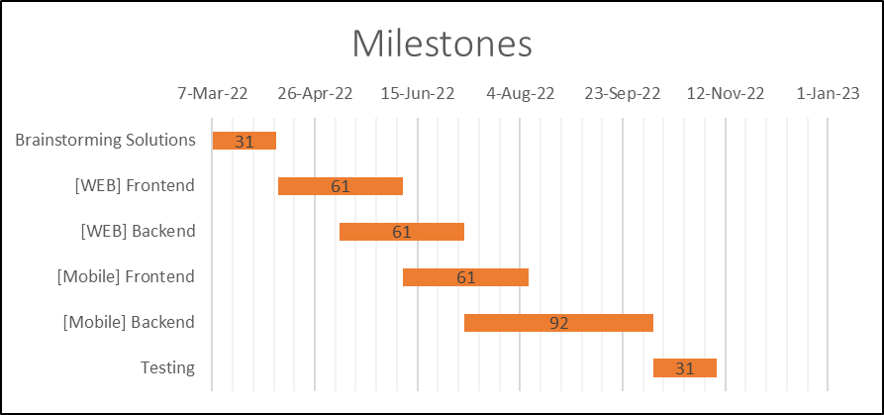

Since the project needs completion in the coming 12 months, it would be wise

to dedicate time for each task respectfully. The first month should be spent on

deciding and figuring out the solutions for the problems at hand and hopefully

design the expected front end. The next 2 months could be dedicated to the

implementation of the front end. 2 months more could be dedicated to building

the back end of the application.

In the remaining 7 months, same could be done for Mobile Application

implementation if everything goes as planned.

# 11. References

* Internet Web page: Autodesk. “Autodesk Forge”. Autodesk. [URL](https://forge.autodesk.com).
* Internet Web page: MICHAEL BEALE. “Forge + React Native (AU Talk)”. OCTOBER 26, 2017. Autodesk. [URL](https://forge.autodesk.com/blog/forge-react-native-au-talk).
* Internet Web page: BRYAN HUANG. “Kick start 2020 with cross-platform Viewer apps in Flutter!”. JANUARY 5, 2020. Autodesk. [URL](https://forge.autodesk.com/blog/kick-start-2020-cross-platform-viewer-apps-flutter).

1. CAD : Computer Aided Design [more info.](https://www.smartdraw.com/cad/)
2. EPR : Enterprise Resource Planning [more info](https://corporatefinanceinstitute.com/resources/knowledge/accounting/enterprise-resource-planning-erp/#:~:text=ERP%20keeps%20track%20of%20a%20wealth%20of%20information%2C%20including%20payroll%2C%20raw%20materials%2C%20business%20commitments%2C%20purchase%20orders%2C%20and%20capacity%20for%20production.)
3. React Native [information](https://reactnative.dev/#:~:text=Create%20native%20apps,app%20from%20scratch.)
4. Autodesk Forge is A cloud-based developer platform from Autodesk [information](https://forge.autodesk.com/#:~:text=Render%203D%20and%202D%20model%20data%20within%20a%20browser.%20The%20models%20can%20come%20from%20a%20wide%20range%20of%20applications%20such%20as%20AutoCAD%2C%20Fusion%20360%2C%20Revit%2C%20and%20many%20more.)